1. Write a program to Show an alert

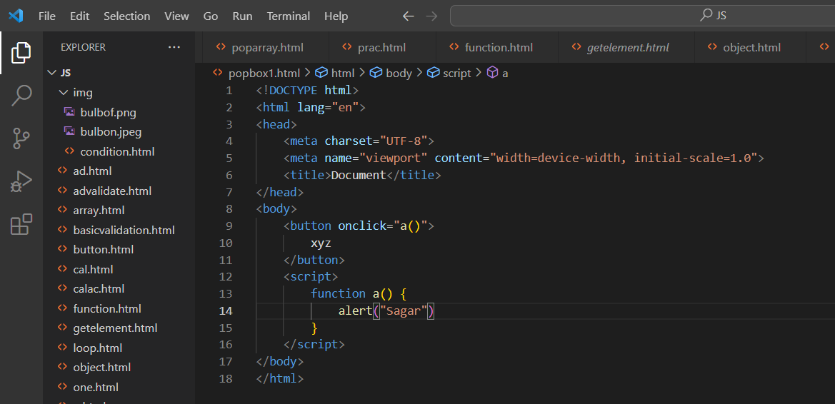

1. What will be the result for these expressions?

* 5 > 4

Result: true

* "apple" > "pineapple"

Result: false

* 2" > "12"

Result: true

* undefined == null

Result: true

* undefined === null

Result: false

* null == "\n0\n"

Result: false

* null === +"\n0\n"

Result: false

1. Will alert be shown?

if ("0") { alert( 'Hello'); }

* Yes, an alert will be shown.

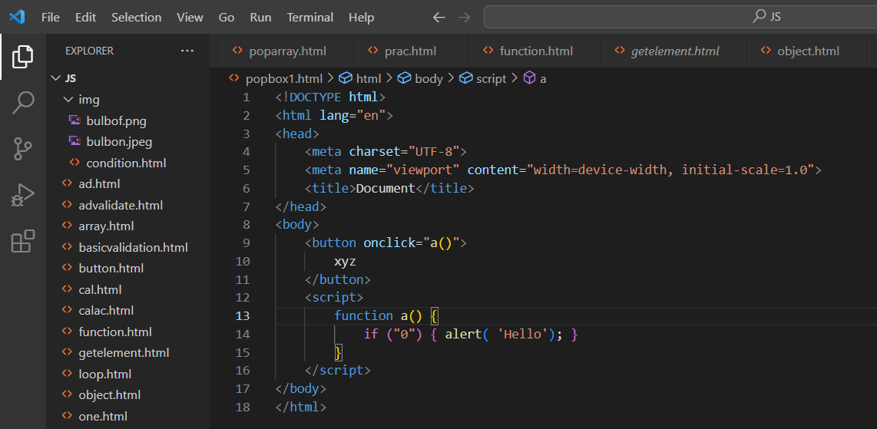

1. What is the code below going to output? alert( null || 2 || undefined );

* **alert(null || 2 || undefined);** will display an alert with the value **2**..

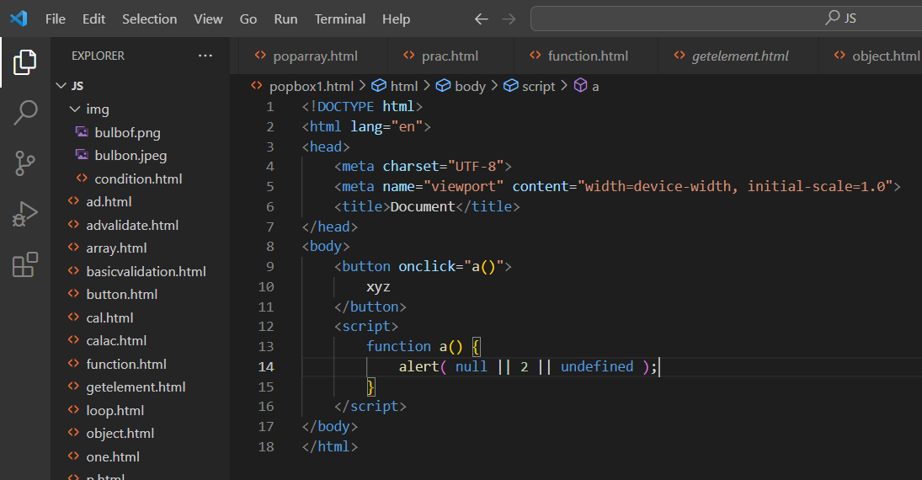

1. The following function returns true if the parameter age is greater than 18. Otherwise it asks for a confirmation and returns its result: function checkAge(age)

{ if (age> 18) { return true; }

else { // ...return confirm (‘did parents allow you?'); } }

* this function checks the age and asks for confirmation if necessary, returning **true** if the age is greater than 18 or if the user confirms, and **false** if the age is 18 or less or if the user cancels the confirmation.

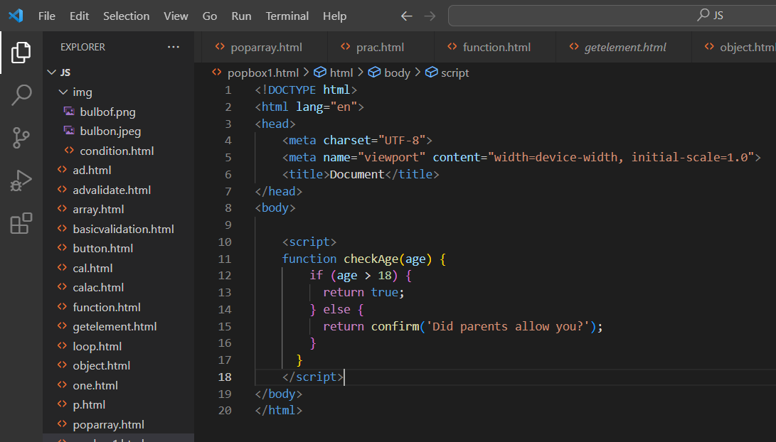

1. Replace Function Expressions with arrow functions in the code below:

Function ask(question, yes, no)

{

if (confirm(question))yes();

else no(); } ask("Do you agree?",

function() { alert("You agreed."); },

function() { alert("You canceled the execution."); } }

* The arrow functions **() => { alert("You agreed."); }** and **() => { alert("You canceled the execution."); }** have the same functionality as the original function expressions.

